Data Warehouse Design Background
This document provides details about the requirements of the data warehouse for CPI Card Group. The requirements provide details about the design and sizes of data sources as well as business reporting needs.

Data Sources
The data warehouse uses three data sources as depicted in Figure 1. The ERP database is the major data source used by manufacturing to manage jobs, subjobs, shipments, and invoices. The lead file and financial summaries are secondary data sources, both in spreadsheet format. The lead file and financial summary are prepared from other data sources used by the marketing and accounting departments.
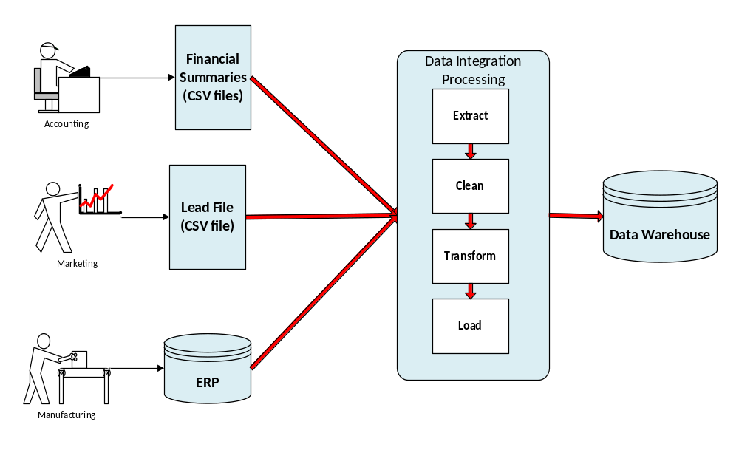
Figure 1: Data Sources for the ABC Data Warehouse

ERP Database Design

The ERP database supports complete processing for jobs involving planning, manufacturing, shipping, invoicing, and payment processing as well as accounting. However, the complete details are not important for this case. Figure 2 shows an abbreviated ERD for the subset of the ERP database relevant for the initial phase of the data warehouse. Table 1 provides a brief description of each table. Appendices A and B contain a complete ERD and details about each column.
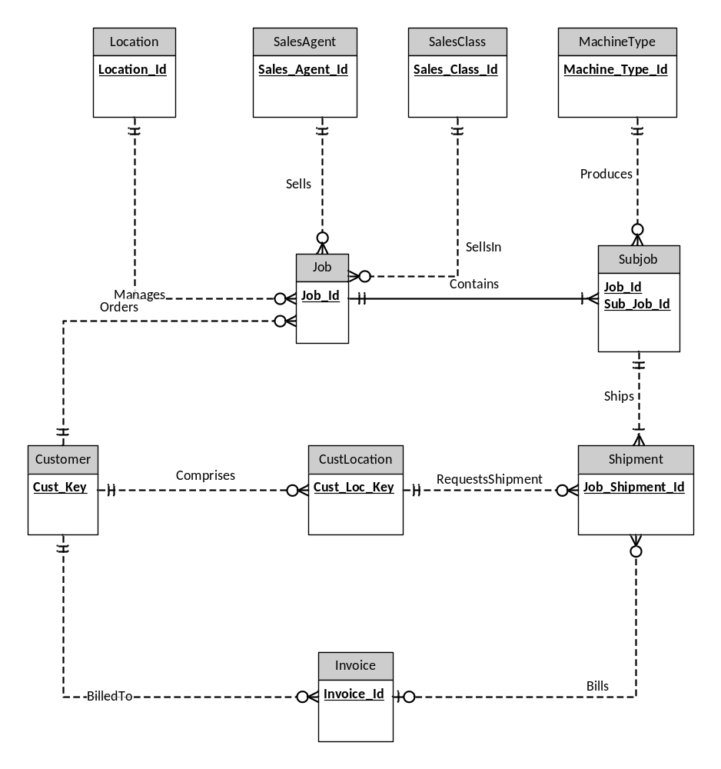
Figure 2: Abbreviated ERD for a Subset of the ERP Database
Table 1: Entity Type Definitions
Entity Type | Comments
Customer | Organizations that request jobs. Customers are involved in quotes which are recorded in the CRM not in the ERP. In the ERP, customers are recorded in a job.
CustLocation | Locations of customers to which cards are shipped.
Invoice | Collection of shipments billed to a customer. An invoice is created after related shipments so the Bills relationship is optional.
Job | A contract for a quantity of cards generated after a customer accepts a quote
Location | Location of the company that manages a job
MachineType | Type of machine used to produce cards in a subjob
SalesAgent | Employee credited with obtaining a job
SalesClass | Type of product on a job
Shipment | Collection of cards shipped to a customer after production in a subjob
SubJob | Subset of a job produced using a machine type. Identification dependent on Job.

The secondary data sources are simpler than the ERP database. Appendices C to E contain details about the secondary data sources.

Sample Data
To clarify the data sources, sample data are provided for the tables of the ERP database as well as the other data sources. Due to number of columns and long column names, the sample data are contained in a separate spreadsheet.

Data Source Size Statistics
To compute grain size, you should use the estimates about cardinalities of tables and unique values of some columns shown in Table 2. The number of rows reflects the current sizes of the data sources with two years of data. For the job, subjob, shipment, and invoice tables, the sizes reflect one year of data as the rows in these tables are archived after one year.

Table 2: Size Estimates for Data Sources
Table | Rows | Comments
Customer | 3,000 | 300 postal codes
CustLocation | 10,000 | 20% of customers have 1 location; remainder have about 4 locations each; 500 postal codes
Invoice | 1,000,000 | 2.5 shipments per invoice
Job | 100,000 | 40% of leads turn into jobs, 50,000 jobs per year
Location | 10
MachineType | 10
SalesAgent | 50
SalesClass | 6
Shipment | 2,500,000 | 5 shipments per subjob on average
SubJob | 500,000 | 5 subjobs per job on average
Lead file | 250,000 | About 125,000 leads per year
Financial Sales Summary | 1,800 | Monthly summary for combinations of sales class and location for 5 years. Assumes sparsity of 70%
Financial Cost Summary | 5,400 | Monthly summary for combinations of sales class, location, and machine type for 5 years. Assumes sparsity of 85%

Business Reporting Needs
The main purpose of the data warehouse is to track and compare sales and costs for major dimensions across time periods. Sales should also be compared to invoiced amounts for major dimensions and time periods. Costs should be tracked by component for labor, machine, overhead, and material so that standard accounting measures can be computed such as gross margin, contribution ratio, and related ratios. In addition, planning performance should be evaluated by comparing sales to forecasts and costs to budgets.

Job and Shipment Performance and Trends
- What are job revenue trends by location over time?
- What are sales agent productivity from leads to jobs over time?
- What are production trends for jobs (time to subjob production) for entities over time?
- What are shipment trends for jobs (contract time to shipment) for entities over time as compared to shipment promised dates and first shipping dates?

Invoice Trends
- Which entities (such as customers, locations, and products) generate the highest invoice amounts over time?
- What are trends for invoicing of job amounts (time to invoice) for entities (locations and products) over time?
- What are trends over time for returns measured by the difference between invoice quantity and shipping quantity for products, machines, and locations?

Financial Performance
- What are the gross margins for a location?
- How much does a location’s gross margin vary from its forecast/budget by month?
- What products are the most difficult to budget or forecast?
- What products and locations are the most profitable over time?

Appendix A: Complete ERD for the ERP Database
The complete ERD (Figure 1) shows all columns including primary keys, foreign keys, and other columns in each table. Note that the primary key of Subjob is a combination of Job_Id and Sub_Job_Id. Foreign keys in bold font indicate that the column is required.
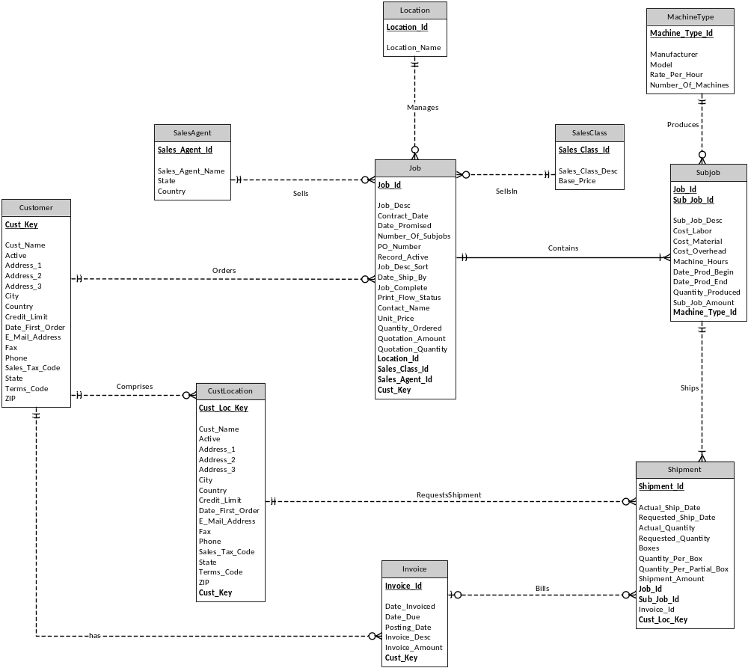
Figure A.1: Complete ERD for a Subset of the ERP Database

Appendix B: Data Dictionary for ERP Columns
The tables in this appendix contain selected details about each column in the ERP database. The DW column indicates if the column has likely value for the data warehouse. You should also see the spreadsheet with example values for each table.

Customer
Column Name | Data Type | Definition | DW
Cust_Key | LONG | unique identifier for customer
Cust_Name | VARCHAR | customer name
Active | BOOLEAN | marks whether the customer is active | No
Address_1 | VARCHAR | customer address line 1 | No
Address_2 | VARCHAR | customer address line 2 | No
Address_3 | VARCHAR | customer address line 3 | No
City | VARCHAR | customer city
Country | VARCHAR | customer country
Credit_Limit | CURRENCY | customer credit limit
Date_First_Order | DATE | date of the customer's first order | No
E_Mail_Address | VARCHAR | customer e-mail address
Fax | CHAR(10) | customer fax number | No
Phone | CHAR(10) | customer phone number | Maybe if parsed
Sales_Tax_Code | CHAR(10) | customer sales tax code | No
State | CHAR(2) | customer state
Terms_Code | CHAR(10) | Indicates payment terms
ZIP | CHAR(10) | customer ZIP code

CustLocation
Column Name | Data Type | Definition | DW
Cust_Loc_Key | LONG | unique identifier for customer location
Cust_Name | VARCHAR | customer location name
Active | BOOLEAN | marks whether the customer location is active | No
Address_1 | VARCHAR | customer location address line 1 | No
Address_2 | VARCHAR | customer location address line 2 | No
Address_3 | VARCHAR | customer location address line 3 | No
City | VARCHAR | customer location city
Country | VARCHAR | customer location country
Credit_Limit | CURRENCY | customer location credit limit
Date_First_Order | DATE | date of the customer location's first order | No
E_Mail_Address | VARCHAR | customer location e-mail address
Fax | CHAR(10) | customer location fax number | No
Phone | CHAR(10) | customer location phone number | Maybe if parsed
Sales_Tax_Code | CHAR(10) | customer location sales tax code; only used for non-commercial customers | No
State | CHAR(2) | customer location state
Terms_Code | CHAR(10) | customer payment terms
ZIP | CHAR(10) | customer location ZIP code
Cust_Key | LONG | identifier of the customer

Invoice
Column Name | Data Type | Definition | DW
Invoice_Id | LONG | Unique identifier of the shipment
Date_Invoiced | DATE | Date the invoice was prepared
Date_Due | DATE | Date the payment should be received; depends on payment terms
Posting_Date | DATE | Date the payment was recorded | No
Invoice_Desc | VARCHAR | Description of the invoice contents | No
Invoice_Amount | CURRENCY | Amount of invoice
Invoice_Quantity | INTEGER | Quantity billed on invoice
Invoice_Shipped | INTEGER | Quantity sent in related shipments; Returns are difference between invoice quantity and shipped
Cust_Key | LONG | identifier of the customer billed on the invoice

Job
Column Name | Data Type | Definition | DW
Job_Id | LONG | Unique identifier of the job
Job_Desc | CHAR(50) | Description of the job. Used only when a job is not complete.
Contract_Date | DATE | Date the job contract was created
Date_Promised | DATE | Date promised for the last shipment of the the job
Number_Of_Subjobs | INTEGER | Number of subjobs associated with the job. The number of subjobs is initially estimated but then updated if the number changes during production.
PO_Number | CHAR(10) | Purchase order number of the job from the customer | No
Record_Active | BOOLEAN | True if the job is active. Only non-active jobs will be stored in the data warehouse. | No
Date_Ship_By | DATE | Date promised for the first shipment
Job_Complete | BOOLEAN | True if job is complete. Usually the same value as Record_Active. | No
Print_Flow_Status | CHAR(10) | Indicates production status. Not useful after a job is completed. | No
Contact_Name | CHAR(50) | Name of the contact for the job. | No
Unit_Price | CURRENCY | Price of each unit created for the job
Quantity_Ordered | SHORT | Number of items ordered
Quotation_Amount | CURRENCY | Dollar amount of the quote to the customer
Quotation_Ordered | SHORT | Number of items initially requested by the customer
Location_Id | LONG | Identifier of the location where the job belongs
Sales_Class_Id | LONG | Identifier of the sales class where the job belongs
Sales_Agent_Id | LONG | Identifier of the sales agent associated with the job
Cust_Key | LONG | Identifier of the customer who placed the order

SubJob
Column Name | Data Type | Definition | DW
Job_Id | LONG | identifier of the job and part of the primary key
Sub_Job_Id | SHORT | identifier of the subjob within the job
Sub_Job_Desc | CHAR(50) | description of the subjob | No
Cost_Labor | CURRENCY | cost of labor for the subjob
Cost_Material | CURRENCY | cost of materials for the subjob
Cost_Overhead | CURRENCY | cost of overhead for the subjob
Machine_Hours | DECIMAL | number of machine hours used for the subjob
Date_Prod_Begin | DATE | date the production of the subjob began
Date_Prod_End | DATE | date the production of the subjob ended
Quantity_Produced | INTEGER | number of items produced for the subjob
Sub_Job_Amount | CURRENCY | dollar value of the items produced for the subjob
Machine_Type_Id | LONG | identifier of the machine type used for the subjob

Shipment
Column Name | Data Type | Definition | DW
Shipment_Id | LONG | unique identifier of the shipment
Actual_Ship_Date | DATE | date the shipment actually occurred
Requested_Ship_Date | DATE | date the shipment was requested by the customer
Actual_Quantity | INTEGER | actual quantity of items shipped
Requested_Quantity | INTEGER | requested quantity of items shipped
Boxes | INTEGER | number of full boxes in the shipment
Quantity_Per_Box | INTEGER | number of items in each box
Quantity_Per_Partial_Box | INTEGER | number of items in the partially filled box
Job_Id | LONG | identifier of the job related to the shipment
Shipment_Amount | CURRENCY | Amount to be billed for shipment
Sub_Job_Id | LONG | identifier of the subjob related to the shipment
Invoice_Id | LONG | identifier of the invoice related to the shipment; null until invoiced
Cust_Loc_Key | LONG | identifier of the related customer location

Location
Column Name | Data Type | Definition | DW
Location_Id | LONG | unique identifier for the location
Location_Name | CHAR(50) | name of the location

MachineType
Column Name | Data Type | Definition | DW
Machine_Type_Id | LONG | unique identifier for machine type
Manufacturer | LONG | manufacturing company of the machine type
Model | VARCHAR | specific model of the machine type
Rate_Per_Hour | CURRENCY | Rate per hour charged for using machine type
Number_Of_Machines | INTEGER | number of available machines

SalesAgent
Column Name | Data Type | Definition | DW
Sales_Agent_Id | LONG | unique identifier for sales agent
Sales_Agent_Name | VARCHAR | sales agent name
State | CHAR(2) | sales agent state
Country | CHAR(25) | sales agent country
Record_Active | BOOLEAN | True if the sales agent is active with the company | No

SalesClass
Column | Data Type | Definition
Sales_Class_Id | LONG | unique identifier for sales class
Sales_Class_Desc | VARCHAR | type of card produced in the job

Appendix C: Data Dictionary for the Financial Sales Summary
This appendix contains selected details about each column in the financial sales summary spreadsheet. The spreadsheet is maintained on a monthly basis for cumulative actual amounts. Forecast amounts are entered annually so the forecast amounts must be compared to the actual amounts in the last month of the year. For other months, actual costs reflect the cumulative year to date but budget costs reflect the annual budgeted costs.
Note that the actual amounts are not just a summation of recognized revenue from the ERP database. The accounting department conducts a monthly reconciliation process to eliminate double counting of internal sales.

Financial Sales Summary
Column | Data Type | Definition
Summary_Sales_Id | LONG | Unique identifier for Financial Summary Sales
Actual_Units | INTEGER | Cumulative actual sales units until the ending date
Actual_Amount | CURRENCY | Cumulative actual sales amount until the ending date
Forecast_Units | INTEGER | Forecasted sales units for the year
Forecast_Amount | CURRENCY | Forecasted sales amount for the year
Location_Id | LONG | Identifier of the location
Sales_Class_Id | LONG | Identifier of the sales class
Begin_Date | DATE | Beginning date of actual units and amounts, usually the first day of the month
End_Date | DATE | Ending date of actual units and amounts, usually the last day of the month

Appendix D: Data Dictionary for the Financial Cost Summary
This appendix contains selected details about each column in the financial cost summary spreadsheet. The spreadsheet is maintained on a monthly basis for cumulative actual amounts. Budget amounts are entered annually so the forecast amounts must be compared to the actual amounts in the last month of the year for clear results. For other months, actual costs reflect the cumulative year to date but budget costs reflect the annual budgeted costs.
Note that the actual costs are not just a summation of costs from the ERP database. The accounting department conducts a monthly reconciliation process to eliminate double counting of actual costs as some shared costs for materials, overhead, and labor can be double counted.

Financial Cost Summary
Column | Data Type | Definition
Summary_Cost_Id | LONG | Unique identifier for Financial Summary Cost
Actual_Units | INTEGER | Cumulative actual units until the end date
Actual_Labor_Cost | CURRENCY | Cumulative actual labor costs until the end date
Actual_Material_Cost | CURRENCY | Cumulative actual material cost until the end date
Actual_Machine_Cost | CURRENCY | Cumulative actual machine cost until the end date
Actual_Overhead_Cost | CURRENCY | Cumulative actual overhead cost until the end date
Budget_Units | INTEGER | Annual budgeted units
Budget_Labor_Cost | CURRENCY | Annual budgeted labor cost
Budget_Material_Cost | CURRENCY | Annual budgeted material cost
Budget_Machine_Cost | CURRENCY | Annual budgeted machine cost
Budget_Overhead_Cost | CURRENCY | Annual budgeted overhead cost
Location_Id | LONG | Identifier of the location
Machine_Type_Id | LONG | Identifier of the machine type
Sales_Class_Id | LONG | Identifier of the sales class
Begin_Date | DATE | Begin date of actual costs, usually the first day of the month
End_Date | DATE | End date of actual costs, usually the last day of the month

Appendix E: Data Dictionary for the Lead File
The lead file is extracted from the Customer Relationship Management (CRM) system periodically. The identifiers for customers, locations, sales agents, and sales classes are sometimes inconsistent with the ERP tables as the ERP database do not have a convenient interface.

Lead File
Column | Data Type | Definition
Lead_Id | LONG | unique identifier for lead
Quote_Qty | INTEGER | number of items quoted for a lead
Quote_Price | CURRENCY | price per item quoted for a lead
Quote_Value | CURRENCY | dollar total quoted for a lead
Success | BOOLEAN | marks whether the lead turns into a job
PO_Number | LONG | purchase order number if the lead turns into a job
Created_Date | DATE | date the lead was generated
Cust_Id | LONG | identifier of the customer associated with the lead
Location_Id | LONG | identifier of the location associated with the lead
Sales_Agent_Id | LONG | identifier of the sales agent associated with the lead
Sales_Class_Id | LONG | identifier of the sales class associated with the lead

The details are based on the requirements faced by CPI Card Group but have been simplified for usage in this course.

